**PROPOSAL FOR DEVELOPMENT OF WEBSITE**

**Ascentis Global**

Ascentis Global App Development Division is a dedicated software development center. We build robust business products, websites, mobile applications and custom software solutions for startups and large-scale businesses:

**OUR GOAL:**

Our team is dedicated to developing solutions that help organizations and businesses to transform their ideas into implementable business. We build apps with the following goals in mind:

• Produce websites which are simple, user friendly and standardized.

• Design websites that can be easily configured to solve new business challenges.

• Create websites which are easily accessible by organizational members and clients.

**WHAT WE CAN DEVELOP FOR YOU:**

Based on your requirements, our team shall develop a complete solution as envisaged in your concept. It will cover the functionalities of your concept and reproduced below for reference.

**OUR APPROACH:**

Every business starts with an idea. Our business is to turn those ideas into reality.

**Ascentis Global** is your all-in-one service for web design, information technology solutions. Every job is tailored to your exact requirements ensuring a cost-effective solution.

Our professional team ofweb developers and system administrators are talented and enthusiastic about their work and focus on delivering great results. We produce some of the most stunning designs in the market by placing creativity and out of the box thinking at the center of our business.

Communication is the key to any successful project, and as such we keep you up to date at all the stages of planning, design and development. You won’t be left in the dark and will be able to easily track the progress of the job.

**Our Clients**

**Learning Well: (http://www.learningwell.pk/)**



**Middle East Vendors: (https://www.mevendors.qa/)**

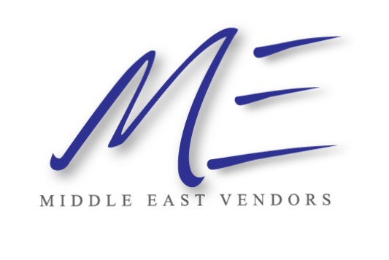

**Prima CRM: (http://www.primabilling.com/)**



**OLCC: (http://olcc.pk/)**



**EXPERTISE:**

Ascentis Global has the expertise in producing user friendly software, web and mobile applications which falls in the following domain

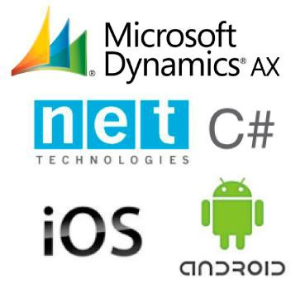• **Microsoft:**

C#, Net Framework, ASP.Net, Web Forms, ASP.Net MVC Entity Framework, Hibernates, MS SQL, WPF

• **Open Source:**



PHP, Maria DB, Codeigniter, Laravel, Angular, Vue

• **Mobile Technologies:**

IOS, Android

• **Other Technologies**

XML, HTML, CSS, JavaScript

**Features of Website:**

**Home page**

* Registration/login for Suppliers
* Registration/login for Buyer
* Display mega menu for product categories
* Home
* About
* Products
* Contact Us
* Forum (where people can discuss, post their question and seek for help)

**Buyer (User)**

* User can search material and go through catalogues of different vendors. User can click and enhance product image to check its quality (max visibility)
* Users can contact sellers regarding product through given contact. (After Login)
* User can share product through social media, SMS, email, WhatsApp.
* Users have their own accounts to maintain a shortlist of items for future. (After Login)
* Users can login through social media and other simple login and register. Can also use the website in guest mode. (On guest mode user cannot access login restricted pages)
* Users can check complete items from a specific vendor by clicking vendor name under their product.
* A registered user can write a review/rating for any vendor but requires admin approval (After Login)
* Users can compare products.
* User can report to admin, if an item is out of stock but still showing as in stock (required to maintain the site integrity)
* Create buying request with product name, quantity and unit.
* Ability to receive and send enquires.

**Admin**

* Login through secure username and password.
* Ability to change Password

**Dashboard**

* Total Number of Registered Suppliers.
* Total Number of Products.
* A copy of customer-seller query or communication view.
* Ability to approve buying request

**Manage Users**

* Ability to view list of all registered Suppliers
* Ability to add Suppliers by providing required details.
* Ability to Approve Supplier Accounts.
* Ability to active/inactive Suppliers and Buyers Account.
* Ability to delete Suppliers and Buyers Account.

**Manage Category**

* Ability to add, edit or delete category

**Manage products**

* Ability to view list of all products
* Ability to edit, delete all products

**Suppliers**

**Profile**

* Ability to Edit Profile
* Ability to change Password

**Product:**

* Ability to view list of all his products.
* Ability to add new products with image.
* Ability to edit product.
* Ability to active/inactive products.
* Manage Item Stock.
* Ability to receive and send enquires.

**Project Design and Development Plan:**

 Designing

 Front End HTML5

 Development

 S.Q.A

 Technology

**DESIGNING**:

• Template will be provided by the client, pages which are not available in the template will be designed when required.

**WEBSITE HTML:**

• Responsive HTML, Browser Compatibility

• Multi-Platform Support (Desktop, Mobile, Tablet etc.)

**DEVELOPMENT:**

• After finalization of the website design from your end, our team will start working on the website.

• Our team will develop website as per finalized requirement.

**S.Q.A:**

• After the development phase of the Website, our quality assurance team will test out the functionality, UI and UX of the website

**TECHNOLOGY:**

**Website and Portal:**

• Front end: HTML5, CSS3, J-Query

• Database: MariaDB

• Framework: Codeigniter/ Laravel

• Language: PHP

|  |  |  |
| --- | --- | --- |
| **TOTAL COAST OF PROJECT** | | |
| Website (Design and Development) | Rs. 130,000/= | |
|  | **Cost of Project** | Rs. 130,000/= |

|  |
| --- |
| **Client will provide following** |
|  |
| **Domain** | |
| **Hosting:**  Testing server | |
| **Content of Website:**  Product Fields, Supplier and buyer Registration Fields, Category list, About us, Contact us, terms and conditions,  privacy and policy | |
| **Logo:**  Website Logo | |
| **Template:**  https://aazztech.com/product/martplace-multipurpose-online-marketplace-html-template/ | |
| **Sms Gateway:**  http://sendpk.com/pricing_pakistan.php | |
| **Email Server:**  https://www.smtp2go.com/pricing/ | |

**DELIVERY SCHEDULE FOR WEBSITE AND APPLICATIONS:**

• After finalization of layout, work will be started on project and will be delivered after 35 working days.

Forum will be started after main website is done (Required 10 working days).

**SCHEDULE OF PAYMENT:**

• **25%** at the time of Contract.

• **50%** at the time of 50% website completion.

• **25%** at the time final delivery

**SUPPORT & SERVICES:**

• Our services include One-month free implementation support for the system free support through e-mail and on call service.

• The support includes queries related to usage of software, maintenance and resolving any software issues that arise.

• Once the website is deployed you can avail our support through Skype, Phone

Calls, Email and Team Viewer.

• Free support will expire after 1 month from the date of first beta deployment.

• You can request website and applications customization as per your requirement but all the customizations will be charged separately.

• If the client does not wish to continue our support, then each visit or support session to the client will be charged separately.

**TERMS & CONDITIONS:**

• Support contract must be minimum 1 year

• Billing cycle for support will be 1 year and payment will be paid in advance.

• All the prices are exclusive of any taxes.

• All application support will be provided during our operation time which is 09:00 am to

6:00 pm Monday to Friday.

• For any reason if the client cancels the deal with in the first 15 days of contract signing date, he will receive 50% of advance payment.

• In case the contract is cancelled from Ascentis Global in first 30 days of contract signing date, client will receive a full refund of their advance payment.

**Regards,**